**Name: SHAMJAD MAZOOD NAZER**

**Roll No: 36**

**Batch: RMCA - B**

**Date: 19-04-2022**

**ADVANCED DATABASE MANAGEMENT SYSTEM LAB**

**Experiment No.: 4**

**Aim**

To familiarize with aggregate functions

**Questions**

1.List total loan

2.List total deposit

3.List total loan taken from KAROLBAGH branch

4.List total deposit of customers having account date later than 1-Jan-96

5.List total deposit of customers living in city NAGPUR

6.List maximum deposit of customer living in Bombay

7.List total deposit of customer having branch in BOMBAY

 8.Count total number of branch cities

9.Count total number of customers cities

10.Give branch names and branch wise deposit

11.Give city wise name and branch wise deposit

12.Give the branch wise loan of customer living in NAGPUR

13.Count total number of customers

14.Count total number of depositors branch wise

15.Count total number of depositors branch wise

16.Give maximum loan from branch VRCE

17.Give the number of customers who are depositors as well as borrowers

**Procedure**

use bank_lab_cycle_2;

SELECT SUM(AMOUNT) FROM borrow;

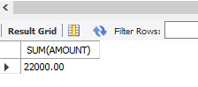

SELECT SUM(AMOUNT) FROM deposit;

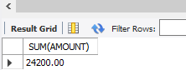

SELECT SUM(AMOUNT) FROM borrow WHERE BNAME="AJNI";

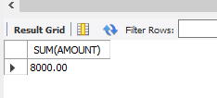

SELECT SUM(AMOUNT) FROM deposit WHERE ADATE>'1996-01-01';



SELECT SUM(D1.AMOUNT) FROM deposit D1, customer C1 WHERE C1.CITY="NAGPUR" AND C1.CNAME=D1.CNAME;

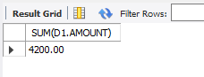

SELECT MAX(D1.AMOUNT) FROM deposit D1, customer C1 WHERE C1.CITY="BOMBAY" AND C1.CNAME=D1.CNAME;

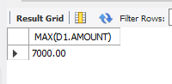

SELECT SUM(D1.AMOUNT) FROM deposit D1, customer C1 WHERE C1.CITY="BOMBAY" AND C1.CNAME=D1.CNAME;

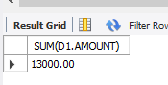

SELECT COUNT(DISTINCT(CITY)) FROM branch;

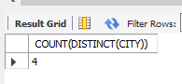

SELECT COUNT(DISTINCT(CITY)) FROM customer;



SELECT BNAME,SUM(AMOUNT) FROM deposit GROUP BY BNAME;

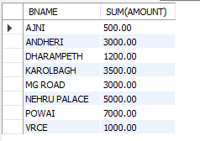

SELECT C1.CNAME,SUM(D1.AMOUNT) FROM customer C1, deposit D1 WHERE D1.CNAME=C1.CNAME GROUP BY C1.CITY;

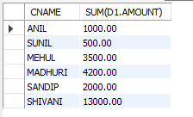

SELECT BNAME,SUM(AMOUNT) FROM borrow, customer WHERE CITY="NAGPUR" GROUP BY BNAME;

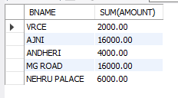

SELECT COUNT(CNAME) FROM customer;

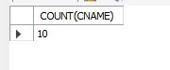

SELECT BNAME, COUNT(*) FROM deposit,customer WHERE deposit.CNAME=customer.CNAME GROUP BY BNAME;

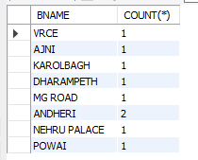

SELECT MAX(C1.AMOUNT) FROM branch B1, BORROW C1 WHERE C1.BNAME="VRCE" AND C1.BNAME=B1.BNAME;



SELECT COUNT(DISTINCT(D1.CNAME)) FROM DEPOSIT D1, BORROW B1 WHERE B1.CNAME=D1.CNAME;



**Output Screenshot**

**Name: SHAMJAD MAZOOD NAZER**

**Roll No: 36**

**Batch: RMCA - B**

**Date: 19-04-2022**

**ADVANCED DATABASE MANAGEMENT SYSTEM LAB**

**Experiment No.: 5**

**Aim**

To familiarize with set operations

**Questions**

1. List all the customers who are depositors but not borrowers.
2. List all the customers who are both depositors and borrowers.
3. List all the depositors having deposit in all the branches where Sunil is having Account.
4. List all the customers living in city NAGPUR and having branch city BOMBAY or   DELHI.
5. List all the depositors living in city NAGPUR.
6. List all the depositors living in the city NAGPUR and having branch in city BOMBAY.
7. List the branch cities of Anil and Sunil.
8. List the customers having deposit greater than 1000 and loan less than 10000.
9. List the cities of depositors having branch VRCE.
10. List the depositors having amount less than 1000 and living in the same city as Anil.
11. List all the cities where branches of Anil and Sunil are located.
12. List the amount for the depositors living in the city where Anil is living.

**Procedure**

USE bank_lab_cycle_2;

SELECT CNAME FROM DEPOSIT where cname not in(SELECT CNAME FROM BORROW);

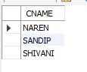

select cname from deposit where cname in (select cname from borrow);

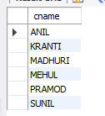

SELECT D1.CNAME FROM DEPOSIT D1 WHERE D1.BNAME IN (SELECT D2.BNAME FROM DEPOSIT D2 WHERE D2.CNAME = 'SUNIL' );



SELECT C1.CNAME FROM CUSTOMER C1,DEPOSIT D1, BRANCH B1 WHERE C1.CITY ='NAGPUR' AND C1.CNAME = D1.CNAME AND D1.BNAME = B1.BNAME AND B1.CITY IN('BOMBAY','DELHI');

SELECT Distinct(CUSTOMER.CNAME) from CUSTOMER,DEPOSIT WHERE City='NAGPUR';

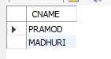

SELECT B1.CITY FROM DEPOSIT D1, BRANCH B1 WHERE D1.BNAME = B1.BNAME AND D1.CNAME IN ('SUNIL' ,'ANIL');

